

Report Paper
CyberLab Project Fall 2025
Reconnaissance & Vulnerability Mapping on OWASP Juice Shop

By
Mario Makhlouta A2220007
Antoine Lahoud A2220266
Abdallah minawi

Presented To
Dr. Nayla Greige

University of Balamand

Department of Electrical and Computer Engineering

CPEN310 Cybersecurity Lab

Contents
Introduction: 2
Objective: 3
Environment Setup & Installation 3
Virtual Machine Configuration 3
Installing OWASP Juice Shop (Without Docker) 3
Reconnaissance 3
Passive Reconnaissance 3
Active Reconnaissance 4
Vulnerabilities Identified 5
Vulnerability 1 — Broken Authentication (Password Cracking) 5
Vulnerability 2 — SQL Injection 9
Vulnerability 3 — Sensitive Data Exposure / Security Misconfiguration 12
Vulnerability 4 — Cross-Site Scripting (XSS) 16
Conclusion 18

Introduction:
This report documents a security assessment of OWASP Juice Shop, a purposely vulnerable web application used for penetration-testing training. The project aims to replicate a real-world web security audit by installing Juice Shop locally, performing reconnaissance, identifying vulnerabilities, and demonstrating controlled exploitation in a safe environment. Using tools such as Nmap, Gobuster, Nikto, curl, and Burp Suite, we analyzed the application's structure, discovered hidden components, and confirmed several exploitable weaknesses. The findings are presented in a clear, pentest-style format with explanations and recommended countermeasures.

Objective:
The objectives of this project are to:
- Install and configure OWASP Juice Shop on a local VM without Docker.
- Perform passive and active reconnaissance to map the application.
- Identify and explain four vulnerabilities found in Juice Shop.
- Use common web-testing tools to support discovery and exploitation.
- Provide a professional report with findings, demonstrations, and mitigation recommendations.

Environment Setup & Installation

Virtual Machine Configuration
- The testing environment was prepared on a dedicated Kali Linux virtual machine to ensure isolation and safety during exploitation.
VM specifications:
- Operating System: Kali Linux (latest version)
- CPU: 2 vCPUs
- RAM: 2 GB
- Storage: 20–30 GB
- Network Mode: NAT (with optional port forwarding for host access)
This setup provides a stable and secure environment for running OWASP Juice Shop and performing reconnaissance using built-in security tools.

Installing OWASP Juice Shop (Without Docker)
As required by the Cyber Lab guidelines, Docker was not used in this project. Juice Shop was installed directly on the VM using Node.js.

Installation Steps
- Update system packages:
sudo apt update

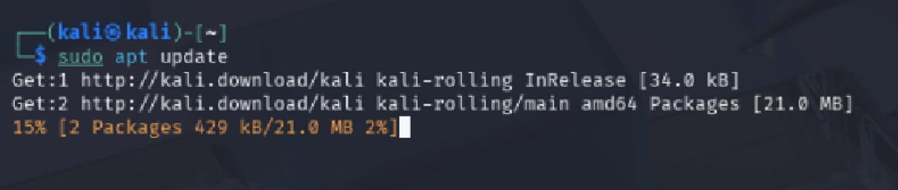

- Downloading OWASP Juice Shop:
sudo apt install juice-shop
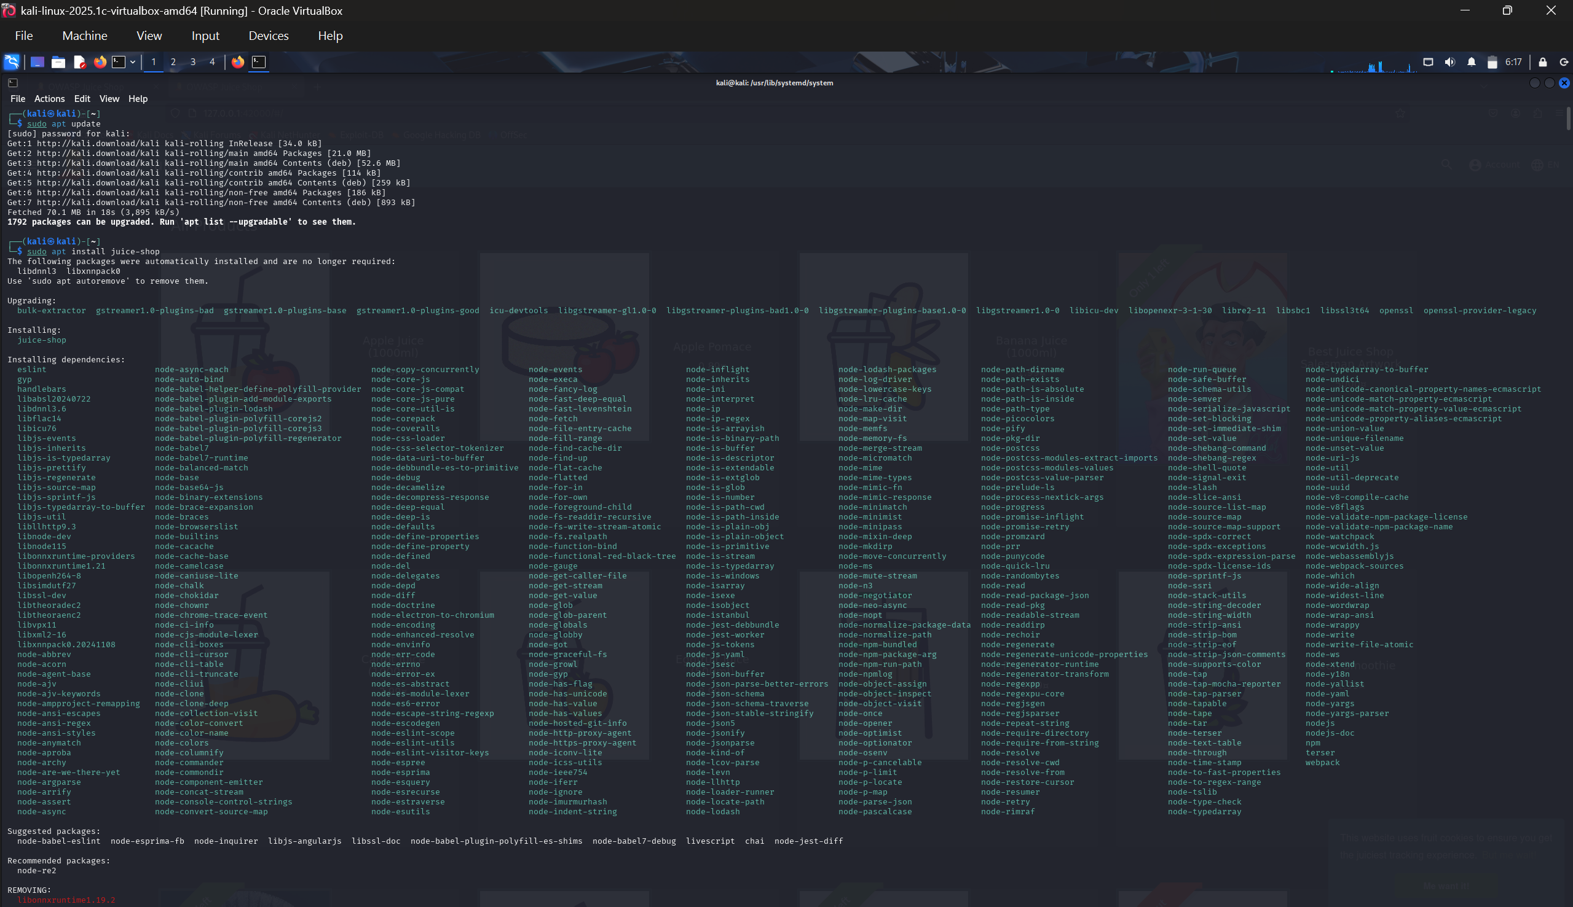

- Hosting the website on the kali machine:
sudo juice-shop

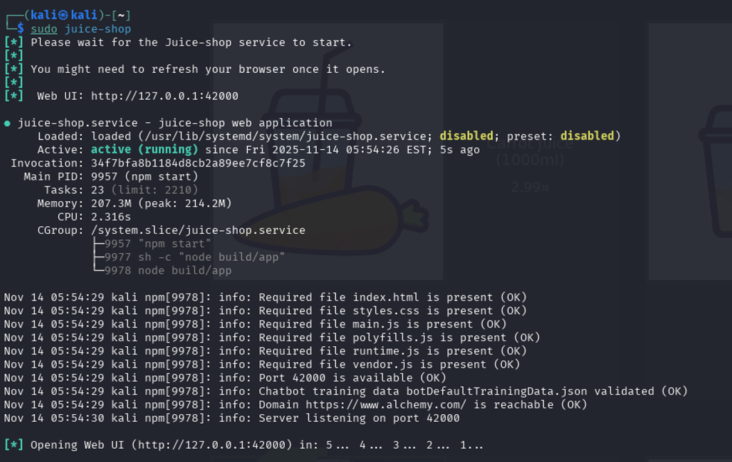
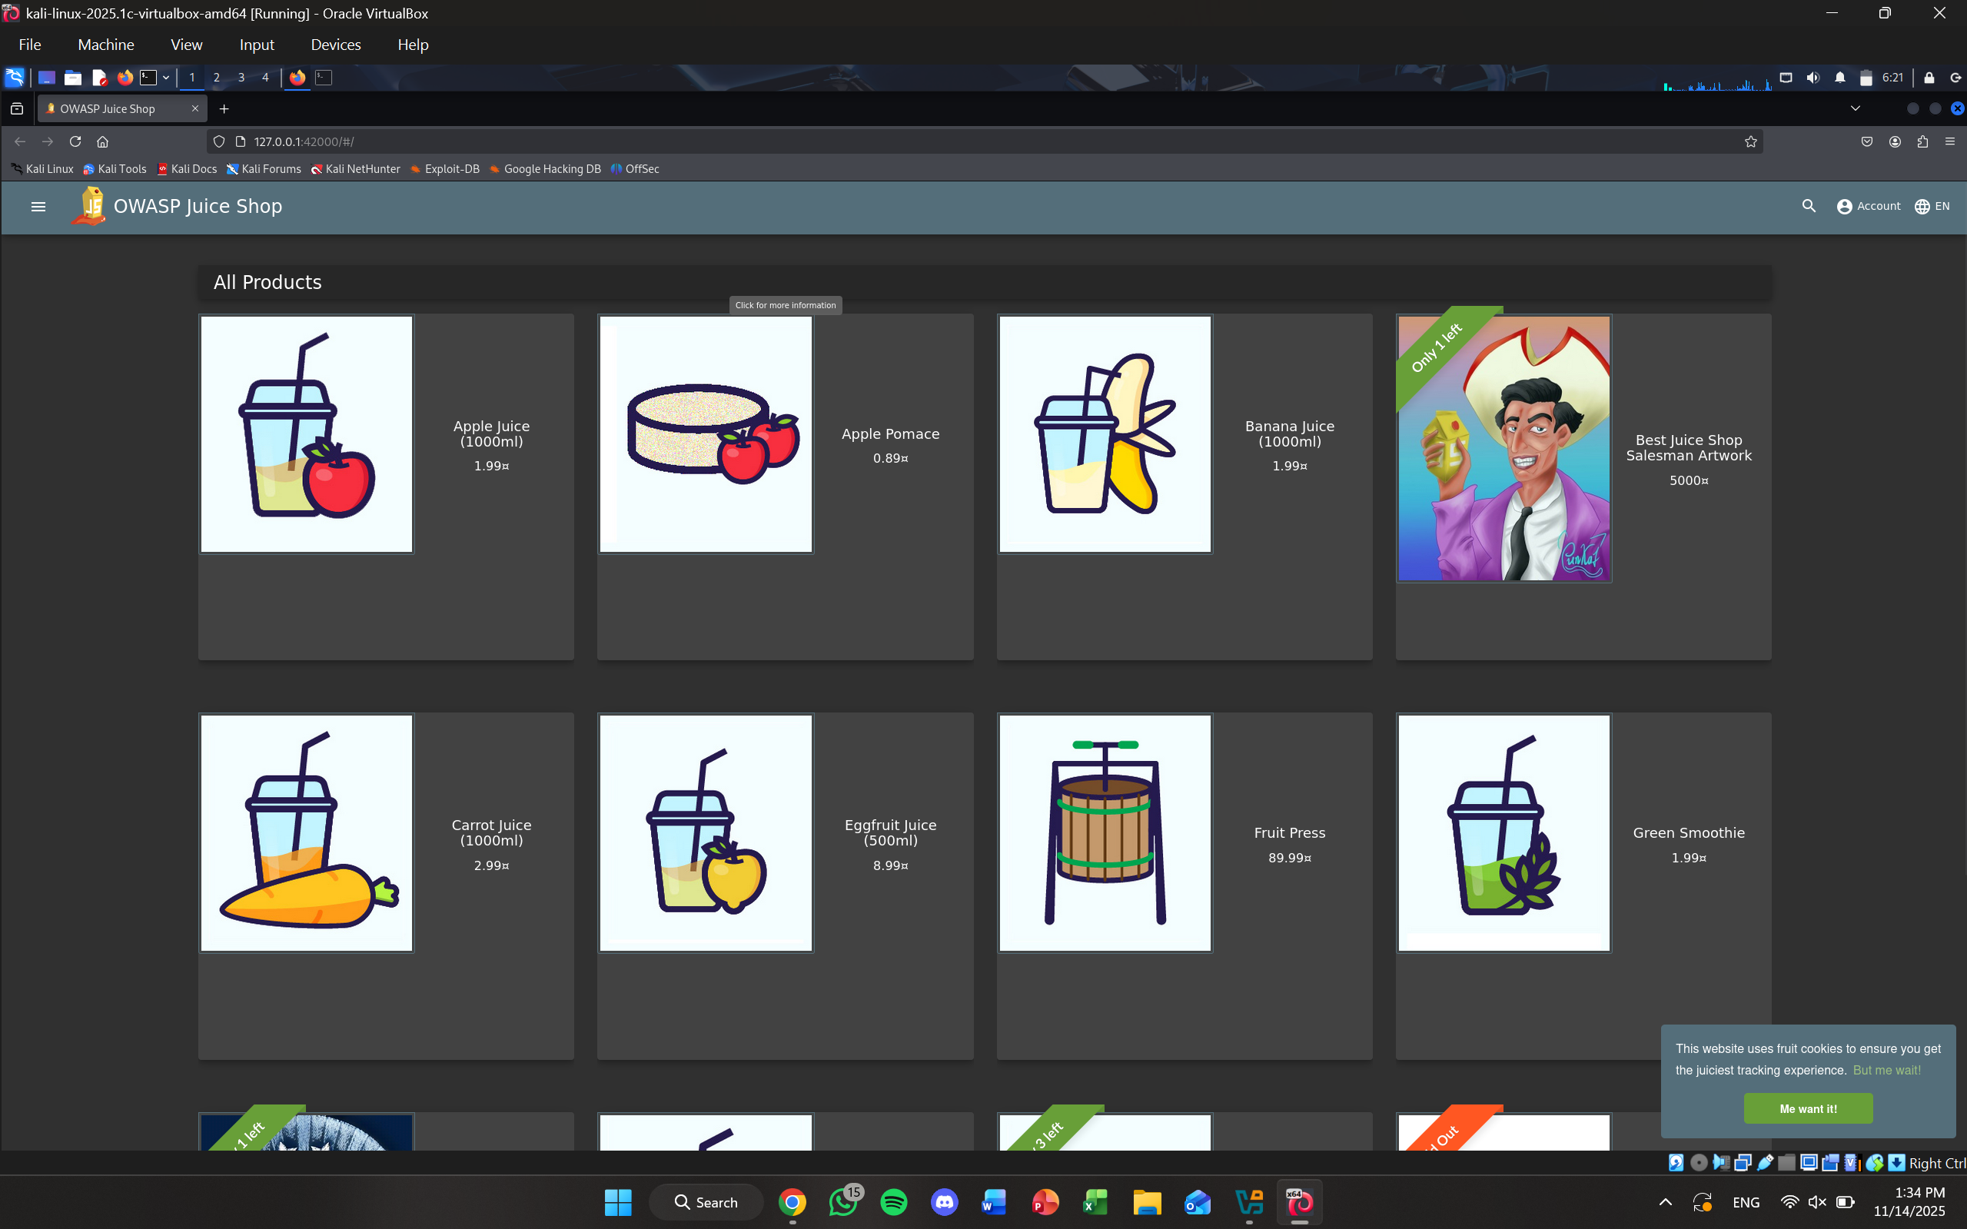

Reconnaissance
Reconnaissance is the first phase of a penetration test and aims to gather information about the target without directly exploiting it. For OWASP Juice Shop, both passive and active methods were used to understand the application’s structure, technologies, and potential entry points.

Passive Reconnaissance
Passive reconnaissance was performed without generating intrusive or high-volume traffic. The goal was to observe how the application behaves under normal browsing conditions.
  - HTTP Header Inspection:
An initial header request was executed using curl to collect basic information about the server.
The response revealed that the application exposes the header X-Powered-By: Express, confirming that it is built on Node.js with the Express framework. No security headers such as Content Security Policy (CSP) or X-Frame-Options were present, indicating minimal server-side hardening.
  - Application Browsing
Manual browsing of the application provided valuable insights. The “About Us” page contained a link to a file served under the /ftp/ directory, suggesting that directory listing might be enabled. Viewing the page’s HTML source also revealed a hidden link to the Juice Shop Score Board (#/score-board), a page that enumerates known vulnerabilities within the application.
  - Input Error Observation
Simple malformed input was tested in the login form to observe how the application handles unexpected characters. Entering:
test'
triggered a raw SQLite syntax error. This confirmed the absence of proper input sanitization and indicated the presence of a potential SQL Injection vulnerability.

Active Reconnaissance
Active reconnaissance was performed using controlled probing techniques to identify additional entry points and exposed components.
  - Port and Service Scanning
A full port scan was performed using Nmap. The scan confirmed that the application was running on port 3000, hosting an Express-based HTTP service. No additional ports were exposed, indicating a relatively limited attack surface from a network perspective.
  - Directory Enumeration
Directory brute-forcing was performed using Gobuster. The scan identified several publicly accessible directories, including:
- /ftp/ — containing .md and .bak files
- /encryptionkeys/ — exposing sensitive key files
The presence of directory listing and accessible backup files indicated weakened server configuration and potential information disclosure issues.
  - Web Vulnerability Scanning
A lightweight scan was executed using Nikto to check for common misconfigurations. The tool confirmed:
- Directory indexing enabled
- Exposed server technology information
- Potentially outdated software components
These findings further supported the possibility of misconfiguration-related vulnerabilities.
  - Proxy-Based Traffic Analysis
Burp Suite was configured as an interception proxy to analyze requests sent by the browser. This technique allowed inspection of key endpoints such as:
- /rest/user/login
- /rest/products/search?q=
- /rest/user/profile
Through this analysis, abnormal behavior associated with SQL injection, reflected XSS, and authentication weaknesses was observed. This information guided the attack paths used during the vulnerability testing phase.

Vulnerabilities Identified

Vulnerability 1 — Broken Authentication (Password Cracking)
- Description
The authentication mechanism of OWASP Juice Shop was found to be critically weak due to the use of unsalted MD5 password hashes. MD5 is an outdated hashing function that can be reversed easily using public cracking databases. During testing, this weakness allowed the extraction of user password hashes, including the administrator’s, and their successful conversion back into plaintext credentials. As a result, attackers can gain full access to privileged accounts without needing to brute-force or guess passwords.

- Steps to Reproduce:

- Extracting user data using a UNION-based SQL Injection
A carefully constructed payload was injected into the search parameter to force the database to return the contents of the Users table. The payload was adapted to match the exact number of columns expected by the query. This produced a response containing user emails and their corresponding MD5 password hashes.
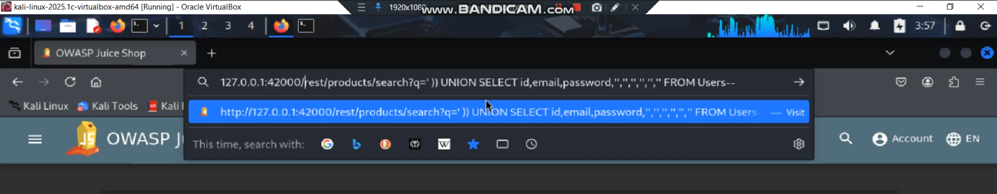

- Identifying the administrator account
Among the returned data, one of the entries corresponded to the administrator user (admin@juice-sh.op). The associated password hash was:

0192023a7bbd73250516f069df18b500

was copied into a new file named hash.txt, as required by John the Ripper’s input format.
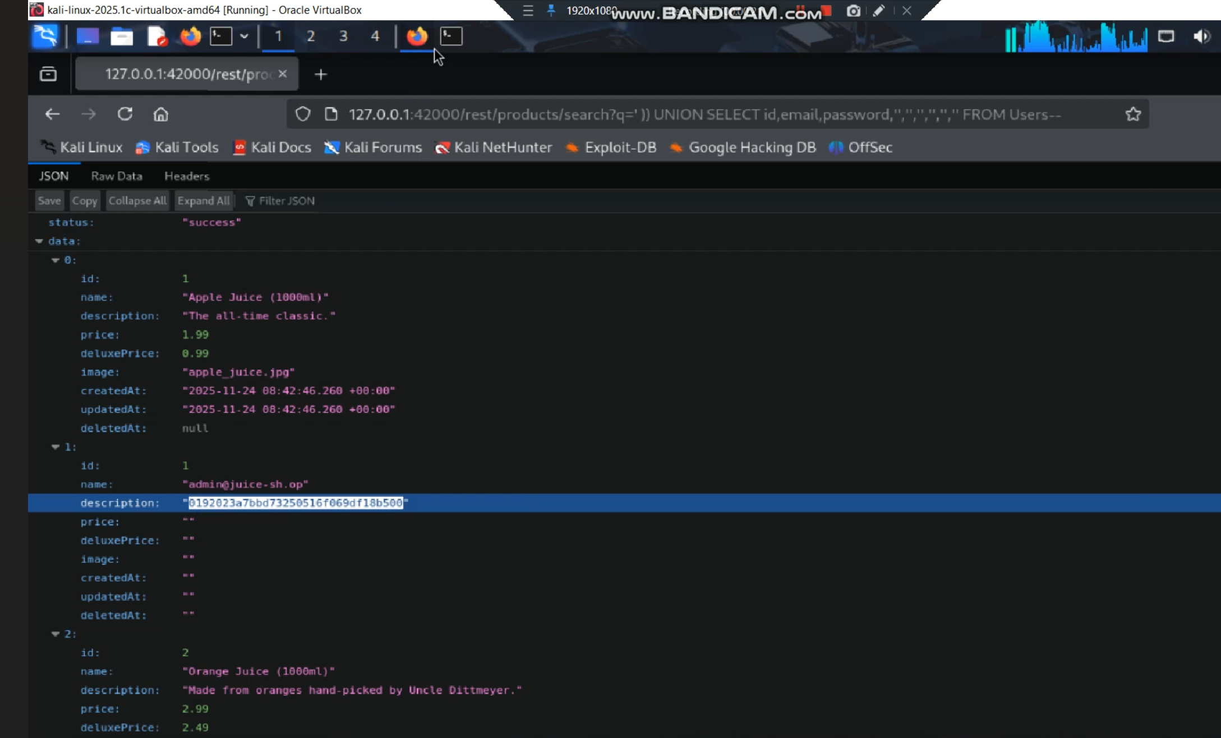

- Executing John the Ripper
Using John the Ripper on Kali Linux, we executed:

john --format=Raw-MD5 hash.txt

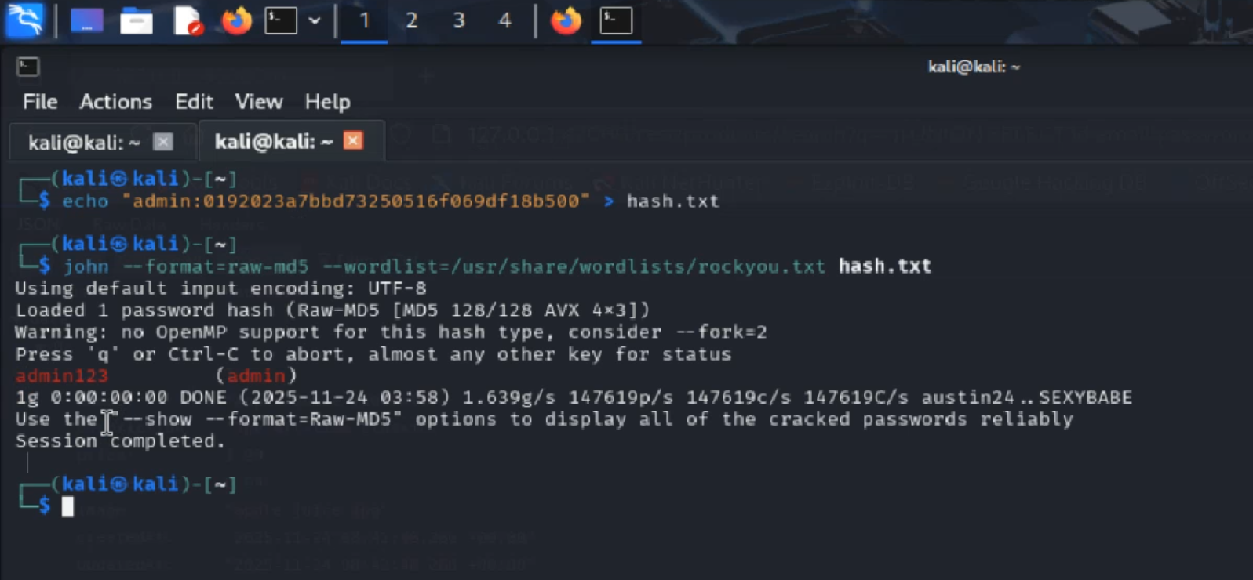

John automatically recognized the hash type and began comparing it against its wordlist. Since MD5 is a fast and weak hashing algorithm, the cracking process completed almost immediately.

- Confirming authentication bypass
Using the retrieved credentials, a login attempt was made through the normal login interface. The application accepted the credentials, confirming that we had successfully gained administrative access without guessing or brute forcing the password.

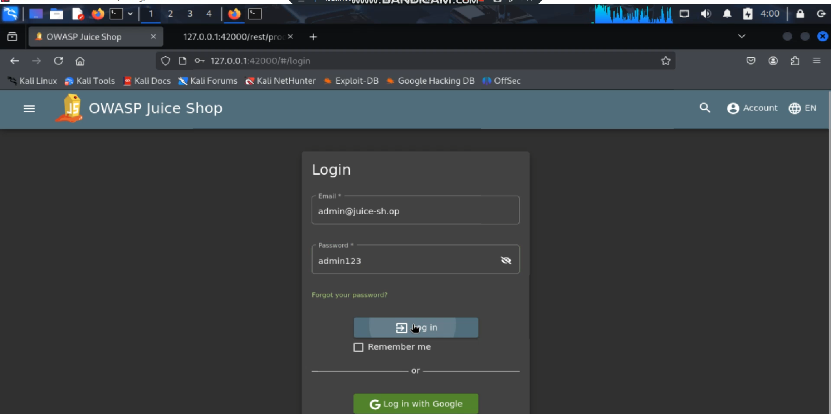

- Post-authentication verification
After logging in, access to privileged pages and administrative-level features confirmed the full compromise. We would now be able to manage user data and perform unauthorized operations on the system.

- Impact
The impact of this vulnerability is severe, as it results in complete compromise of user accounts, including administrative profiles. With the recovered credentials, an attacker can access personal information, modify user data, exploit additional functionalities, and perform administrative actions without authorization. Since MD5 hashes can be cracked almost instantly, the authentication system offers no real protection against credential theft.

- Root Cause
The root cause of this issue is the reliance on insecure cryptographic practices within the authentication workflow. Passwords are stored using MD5 without any salting or strengthening mechanism. In addition, the application lacks protective measures such as login rate limiting, account lockout mechanisms, or MFA. This weakness was further amplified by the presence of SQL injection, which exposed the password hashes in the first place.

- Mitigation Recommendations
To address this vulnerability, the application must replace MD5 with a modern password-hashing algorithm such as bcrypt or Argon2, both of which provide resistance to offline cracking attacks. Passwords should be hashed using unique salts, and the system should enforce strong password policies to discourage predictable or weak credentials. Implementing rate limiting and account lockout policies will significantly reduce the feasibility of automated attacks. Finally, preventing SQL injection is essential to ensure that credential hashes cannot be retrieved by unauthorized parties.

Vulnerability 2 — SQL Injection
- Description
The product search functionality in OWASP Juice Shop was found to be vulnerable to SQL Injection. The application directly incorporates user input into backend SQL queries without validation or sanitization. This allows us to modify the structure of the query, retrieve unauthorized data, and interact directly with the database engine.

- Exploitation – Step-by-Step
- Identifying the Injection Point
we entered a single quote (') in the search bar at /rest/products/search?q=.
The server returned a SQLite syntax error, confirming that user input was processed inside a SQL query.

- Testing for Boolean Injection
we injected:

' OR '1'='1

The output showed all products being returned, proving that the condition was successfully altered, confirming a working SQL injection point.
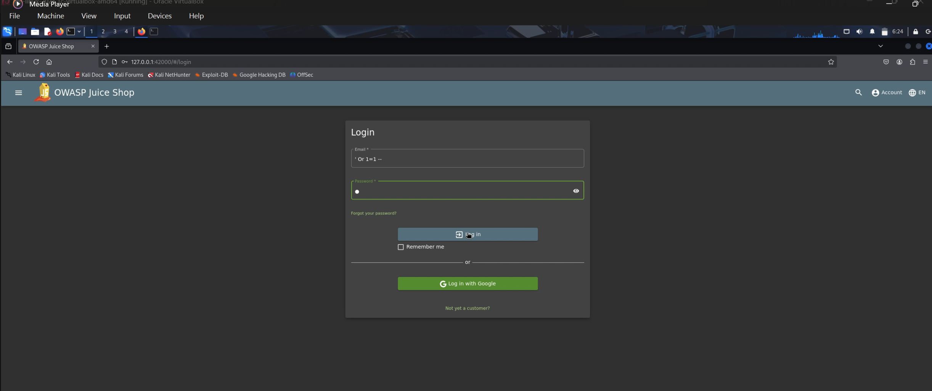
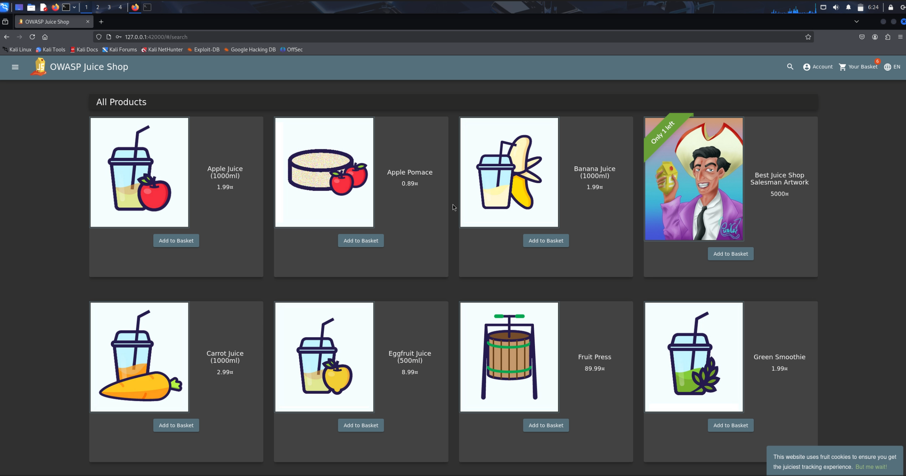

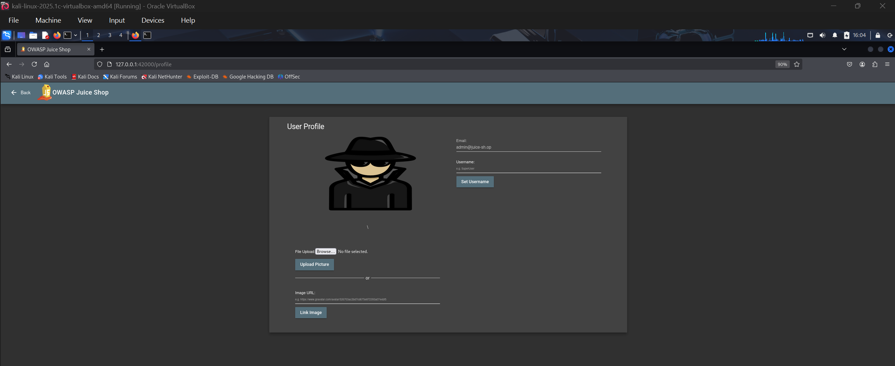

2.2 Similar application of an SQL injection:
- Finding the Correct Column Count
Using Burp Suite Repeater, we tried a series of UNION queries to discover how many columns the original SQL query used:

' UNION SELECT 1--
' UNION SELECT 1,2--
' UNION SELECT 1,2,3—

When the correct number of columns was reached, the application stopped returning errors. This allowed us to prepare a valid UNION injection with the correct structure.

- Extracting User Credentials
After identifying the valid column count, a UNION SELECT payload was crafted to read data from the Users table:

')) UNION SELECT id, email, password, 4, 5, 6, 7, 8, 9 FROM Users—

The product search page returned database entries containing user IDs, emails, and MD5-hashed passwords directly in the interface.

- Locating the Administrator Hash
we reviewed the extracted data and identified the administrator account along with its password hash.
This hash was later cracked using John the Ripper in the previous vulnerability.

- Confirming Data Exposure
By demonstrating the ability to extract sensitive data, we confirmed that SQL injection allowed full read access to the database, proving the severity of the issue.

- Impact
SQL Injection allows an attacker to bypass application logic and directly query the database. This includes reading sensitive user information, exposing credential hashes, and potentially escalating to full database compromise. Since this vulnerability appears in a core API endpoint, it poses a high risk.

- Root Cause
The underlying cause is the absence of input validation and lack of prepared statements in the backend code. The application builds SQL queries by concatenating user-supplied input, making it vulnerable to malicious string manipulation.

- Mitigation Recommendations
The application should adopt parameterized queries or prepared statements to prevent query manipulation. User input must be validated and sanitized before being processed. Additional measures, such as using an ORM and disabling verbose SQL error messages, further reduce exposure to SQL injection attacks.

Vulnerability 3 — Sensitive Data Exposure / Security Misconfiguration
- Description
During reconnaissance, the application was found to expose sensitive directories and files due to improper server configuration. Both the /ftp/ and /encryptionkeys/ directories were publicly accessible without authentication. These directories contained markdown files, backup files, and even cryptographic key material. Directory listing was enabled, allowing an attacker to browse and download files directly. This type of misconfiguration leads to severe information disclosure.

- Exploitation – Step-by-Step
- Identifying Exposed Directories
Using Gobuster during active reconnaissance, the attacker discovered two important directories:
/ftp/
/encryptionkeys/
Both returned a full directory listing, confirming that directory indexing was enabled.

- Accessing the /ftp/ Directory
Navigating to:
http://localhost:3000/ftp/
displayed multiple files, including .md documentation and .bak backup files. The .bak files are typically not intended for public access and often contain sensitive metadata or configuration information.
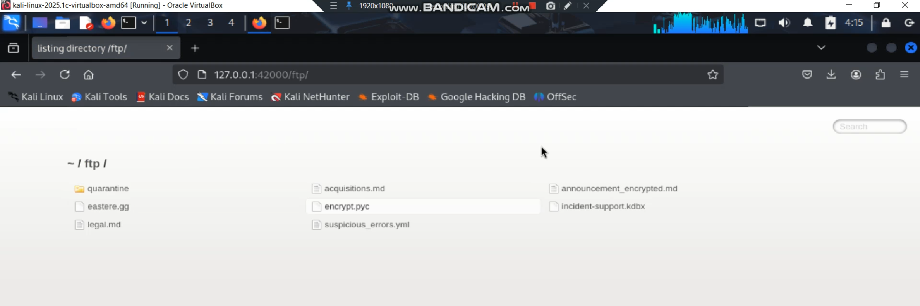
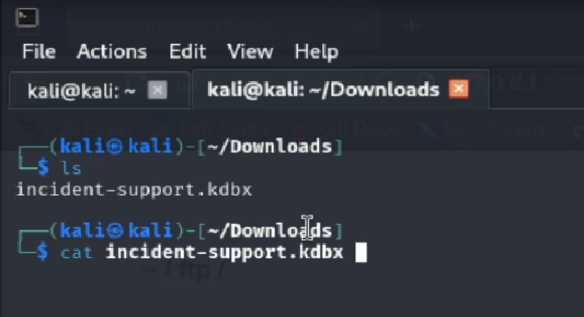
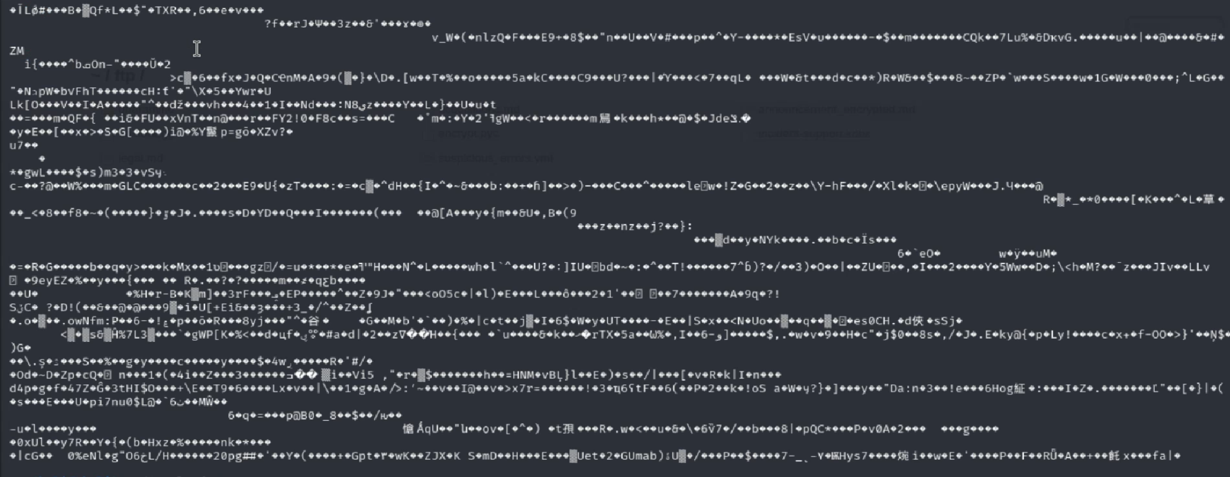

- Accessing the /encryptionkeys/ Directory
The attacker then navigated to:

http://localhost:3000/encryptionkeys/

The directory listing revealed cryptographic key files, including:
jwt.pub
premium.key
These files were downloaded directly and contained sensitive key material used by the application.
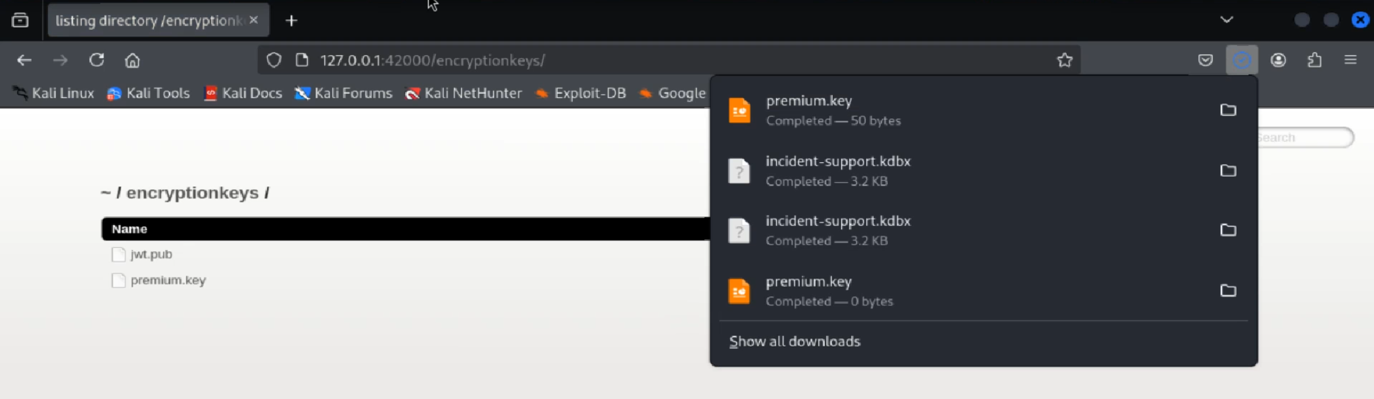

- Reviewing the Exposed Key Files
The downloaded premium.key file contained AES encryption keys in plaintext format, while jwt.pub exposed the public JWT signing key.
In a real-world scenario, such files could allow an attacker to forge authentication tokens, decrypt confidential data, or impersonate privileged users.

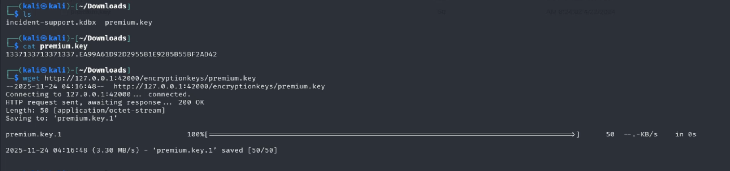

- 6. Confirming Sensitive Data Exposure
By successfully retrieving key files and backup files, the attacker demonstrated that the misconfiguration allowed unauthorized access to sensitive assets. This confirmed that the vulnerability leads to significant information leakage.
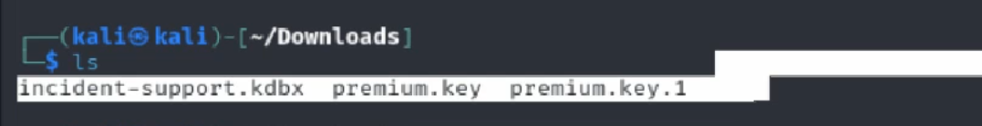

- Impact
This vulnerability can result in full compromise of application confidentiality. Exposed keys may allow attackers to forge tokens, access encrypted information, or escalate privileges. Backup files can reveal internal structure, dependencies, or even hardcoded secrets.

- Root Cause
The root cause is improper server configuration, specifically:
- Directory listing being enabled
- Sensitive files stored within the publicly accessible web root
- No access control restrictions for key and backup files

- Mitigation Recommendations
The application should disable directory listing, move all sensitive files outside the web root, and enforce strict access control. Backup files should be removed from production environments, and cryptographic keys must never be stored in publicly accessible locations. Proper deployment hardening measures, such as using security headers and minimal file exposure, should also be implemented.

Vulnerability 4 — Cross-Site Scripting (XSS)
- Description
The application is vulnerable to Cross-Site Scripting (XSS) due to insufficient sanitization of user-supplied input in the product search feature. The search parameter is reflected directly into the page without encoding, allowing the execution of arbitrary JavaScript code in the user’s browser. This vulnerability can be used to run malicious scripts, steal session data, or manipulate the user interface.

- Exploitation – Step-by-Step
- Locating the Reflection Point
While observing how the search functionality processes input, we noticed that the search term is displayed directly on the page after submission. This indicated that the application reflects unescaped user input back into the HTML.

- 2. Testing a Simple Script Injection
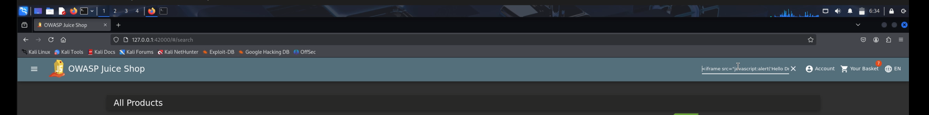
We began by entering:
<script>alert("XSS")</script>
For example here : <iframe src="javascript:alert('Hello Dr Nayla’)”>
into the search bar.
After submission, a JavaScript alert box appeared in the browser, confirming that the script was executed.
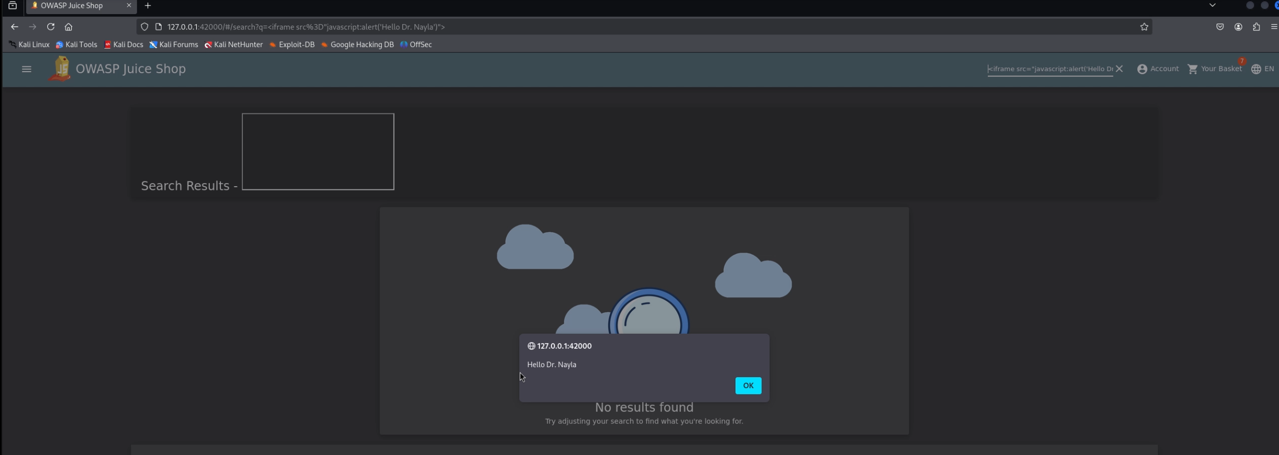

- 3. Inspecting the HTML Rendering
Using the browser’s developer tools, we inspected the section where the search term was displayed. The HTML showed that the input was inserted without HTML encoding. This confirmed that the application renders raw, unsanitized input inside the DOM.

- 4. Verifying Browser Execution Context
To ensure the input was executed within the page’s JavaScript context and not filtered or sandboxed, we tested a modified payload:
<script>console.log("XSS Test")</script>

The message appeared in the console, confirming that we had full execution within the browser’s security context.

- 5. Confirming the Extent of the Vulnerability
Because the script executed consistently across attempts, it demonstrated that the input is not filtered, escaped, or sanitized. This means more complex payloads—such as cookie access scripts, session hijacking, or page manipulation—could also be injected.

- Impact
This Cross-Site Scripting vulnerability allows arbitrary JavaScript execution in the user’s browser. An attacker could steal session cookies, impersonate users, manipulate displayed information, or redirect users to malicious pages. Since the vulnerability exists in a commonly used feature, the risk level is high.

- Root Cause
The primary cause is the lack of proper input sanitization and output encoding. The search parameter is inserted directly into the DOM without escaping special characters, making script execution possible.

- Mitigation Recommendations
The application should sanitize and encode all user-provided input before rendering it in the browser. Framework-level protections or libraries that enforce safe HTML generation should be used. Implementing a Content Security Policy (CSP) can also prevent script execution even if input escapes sanitization. Regular security testing and adoption of secure coding practices will further reduce XSS risks.

Conclusion

This project provided a practical exploration of core web security concepts by analyzing and exploiting vulnerabilities within OWASP Juice Shop. Through systematic reconnaissance, controlled testing, and hands-on exploitation, we demonstrated how weaknesses such as SQL Injection, broken authentication, XSS, and server misconfiguration can lead to significant security breaches. The results highlight the importance of secure coding practices, proper input validation, strong authentication mechanisms, and hardened server configurations.

